**Scales & Perspectives:**  YOU >>> “Who am I? What matters most to me? What am I good at? Where do I find ‘flow’ in my life?” COMMUNITY >>> “How am I cultivating knowledge, experiences, insight and connections in the communities around me?” WORLD >>> “How has/does/will my presence matter? What does the world need more of? How do I plan to participate and contribute to that impression?”

**For the next Informational Interviews**, it’s time to widen your gaze. The first interview most likely took place within the Self to School zone. The next interviews need to take place within the Community zone, as you reach for allies, connections and opportunities in the path beyond high school. The IDEAL CANDIDATE for an Informational Interview is someone who is further (and farther) along the journey in field that YOU are passionate about.

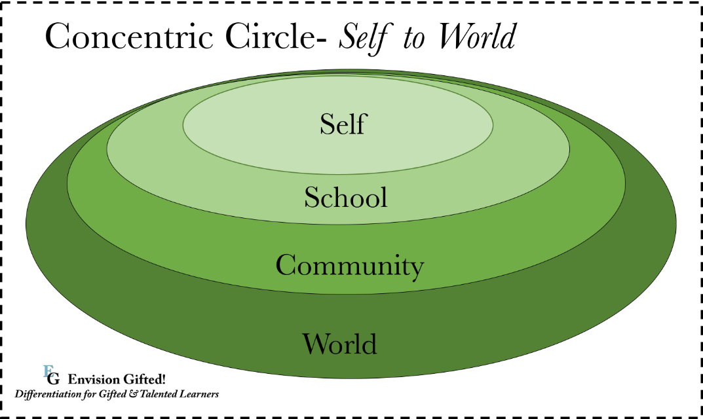

Preparation:

1. **Brainstorm** potential interview candidates within a field that interests you because you have passion and/or skills and talents in that area. Reflect on the principle of Shared Beliefs, Values, Ideas, and Perspectives that are common between those who share a passion, talent and skill set. Explore your resources for these community connections and make a list that includes: name, email, job title and company/school for each candidate.
2. **Contact** the candidate you are most interested in interviewing **via email**. Be sure to construct a professional email with: a greeting, introduce yourself (i.e. full name, AHS, grade level, Honors Internship and field of interest), a request for an Informational Interview, a brief definition of an Informational Interview (i.e. a short discussion on the nature of the field, kinds of jobs, education required, tips and insights), offer to interview on the phone, FaceTime or in person and ask for possible dates/times, and a thank you for considering your request as closure, and finally – sign-off with your professional email signature (i.e. full name, school/grade, email, phone).
3. **Prepare** for your upcoming Informational Interview:
   1. Research the industry, company and interview candidate.
   2. Think about what you would like to learn in the interview – preparation required, education, internships, training, work conditions, career path and advice.
   3. Generate a list of questions that you can draw from during the interview.
   4. Set a reminder the day before the interview/confirm with the interview candidate.
4. **During the interview:** Re-introduce yourself (i.e. AHS, Honors Internship course, field of interest, career path goals). Remind the interview candidate about the purpose of the interview and estimate the time set aside for the interview.
   1. Have your questions on-hand.
   2. Speak clearly.
   3. Be professional and polite.
   4. Invite the candidate to offer insights along the way.
   5. Be prepared to ask impromptu questions.
   6. Remember to say, “Thank you” at the end of the interview.
5. **After the Interview:**
   1. Send a “Thank You” email within 24 hours and mention something specific that you appreciated or learned.
   2. Complete your notes and reflections.
   3. Recognize that you are well on your way to advocating for yourself in the professional world – learning to communicate with authority figures, colleagues and the professional community.

BANK OF INFORMATIONAL INTERVIEW QUESTIONS

**General:**

* What types of jobs are available in this field?
* What types of trainings do most companies offer in this field?
* In what ways is your field changing?
* How is the economy affecting your field?
* What is the employment outlook? How much demand for people in this field?
* What are the areas of growth in this field?
* What is a typical entry-level salary? Potential for salary growth?
* What parts of the country/world are best for opportunities?
* Aside from salaries and benefits, what are the mental and emotional dividends in this career field?
* What skill set and personality traits contribute to success in this field?
* When people leave this career, what are the typical reasons?
* What are the most important things to be aware of and learn about, for someone planning to enter this field

**Specific to this FIELD:**

* What is your exact title and responsibilities?
* What does a typical day look like for you? Schedule, tasks, etc…
* How many hours do you work in a typical week? Overtime? Weekends?
* Do you ever take work home?
* How did you start in this field?
* Has this field been what you expected it to be?
* How much job security do you feel?
* What are the kinds of problems/challenge you deal with?
* How do you solve problems? Who helps you?
* What constraints/obstacles make your job more difficult?
* What is the toughest decision you have made?
* To what extent do you deal with people? Teams? Independent?
* Are you always busy? Do you have time to be creative or reflective at work?
* What part of the job is the most satisfying? Frustrating?
* What is the most interesting experience you have encountered in the job?
* What are the most important skills you possess for the job? How did you acquire them?
* What did you have to acquire educationally for the job? Degree(s)? Credentials? Licenses?
* What are the social obligations in your job?
* How does your job affect your lifestyle? Your health?
* If you could change one thing about your job, what would that be?
* If you left your job or field, what would most likely drive you away? What would you explore instead?

**Preparation for this career path:**

* Does your job relate to any experiences you had in school?
* How well did your education prepare you for this job?
* What courses of study proved to be the most valuable to you?
* What advice do you have for me about continuing education, college, majors?
* How important is a GPA for obtaining a job in this field?
* Are there other things companies are looking for in new hires? Experience? Internships? Other?

**Specific to this Interview Candidate:**

* What is your educational background? High school, college, credentials, licenses?
* What have you studied most?
* How did you get your job?
* What is your work experience?
* What parts of your background have been the most helpful?
* What are you long-term goals for your professional path?
* If your job was suddenly eliminated, what do you feel prepared to do instead?
* If you could do things all over again, would you choose the same path?
* What do you notice in new hires to your field? Positive? Challenges?

**Company Culture:**

* Why did you decide to work for this company?
* What do you like most about the company? What are some challenges?
* How does your company set itself apart from competitors in the industry?
* What does the company do to contribute to its employees’ well-being, loyalty and staying power?
* How do employees give feedback to the company?
* How does the company utilize technology?
* Would you say that employees are mostly autonomous or mostly supervised?
* Are the company’s expectations for schedules, hours, etc.. flexible or set?
* What is the company dress code?
* What are some of the company’s most notable employee benefits?
* How does the interview process work new hires?
* What does the company do to foster innovation and creativity?

**Opportunities and Advancement:**

* How does a person advance in this field?
* What are some of the highest level positions in this field?
* What is a typical career path for advancement?
* What is the average time a person stays in your position?
* How rapidly do most people advance in this field?
* Besides monetary, are there other incentives to advance in this field?
* Do people in this field typically relocate very often?
* If I performed well in this field, where could I expect to be in 5 years?

**General Advice:**

* What should I study or experience after high school to pursue a position in this field?
* How can I assess if I am a good fit for this field?
* What experiences can I look for to prepare for this field?
* What are other jobs or even fields that you feel are similar and worth exploring?
* These are my strongest assets/skills/talents/passions: _________________________________________; where would I fit well in this field?
* What can I do to prepare for the imminent changes in this field?
* Where would you or your company conduct a job search for entry level positions?

**NOTES TO DOCUMENT INTERVEIW: 5-7 questions and notes**

|  |
| --- |
| Question #1: |
|  |

|  |
| --- |
| Question #2: |
|  |

|  |
| --- |
| Question #3: |
|  |

|  |
| --- |
| Question #4: |
|  |

|  |
| --- |
| Question #5: |
|  |

|  |
| --- |
| Question #6: |
|  |

|  |
| --- |
| Question #7: |
|  |

|  |
| --- |
| Evaluate the overall relevance of this interview in 3 BIG TAKE-AWAYS: |
|  |