Name ______________________
Date _______________________

Muscular Endurance Assessment
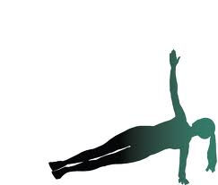
1. Side Stand
Passing Score:
Males – 30 seconds each side
Females – 20 seconds each side

My score: ____________ seconds
Rating: Pass ________ Needs improvement ________

2. Trunk Extension
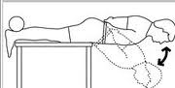
Passing Score:
Males – 20 repetitions
Females – 15 repetitions

My score: _________ repetitions
Rating: Pass _______ Needs improvement _________

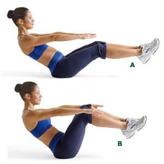
3. Sitting Tuck
Passing Score:
Males – 25 repetitions
Females – 20 repetitions

My score _________ repetitions
Rating: Pass __________ Needs improvement _________

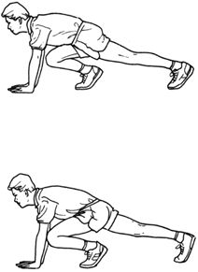
4. Leg Change
Passing Score:
Males/females – 25 changes in 1 minute

My score: _________ repetitions
Rating: Pass ________ Needs improvement __________

5. Bent Arm Hang
Passing Score:
Males – 16 seconds
Females – 12 seconds
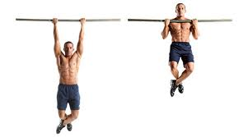
My score: ____________ seconds
Rating: Pass ________ Needs improvement _______

Overall Rating Chart

Muscular Endurance Rating | Number of Tests Passed
Good | 5
Fair | 3 or 4
Poor | <3

Number of tests passed _________
My muscular endurance rating __________

