Students…Adding your Google Email in order to access your school’s bookmarks and ALEKS:

Go into Google Chrome and click on the icon at top right of screen.
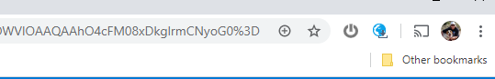

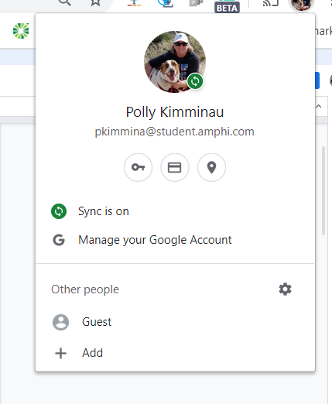
Scroll down and select Add

Type in your name and click ADD at the bottom right of the screen.
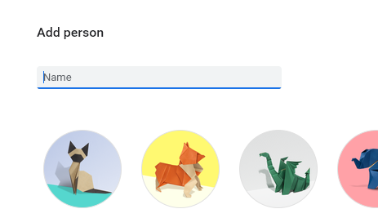

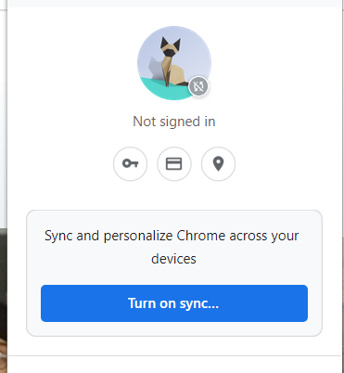
Go up to the new icon at the top right of your screen, click on it and select Turn on sync…

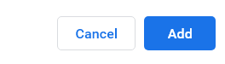

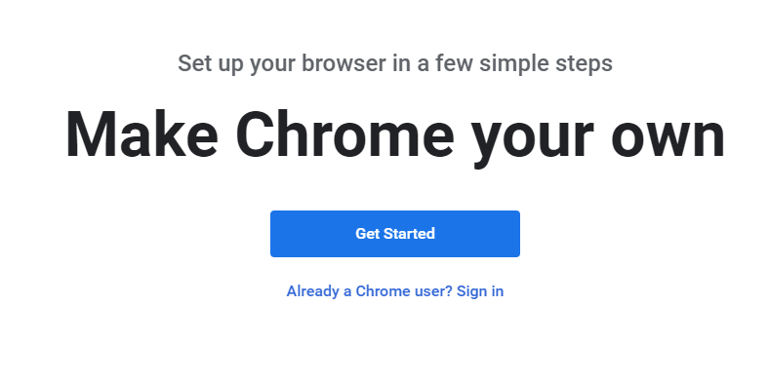
If this screen shows up, select “Already a Chrome user? Sign in”

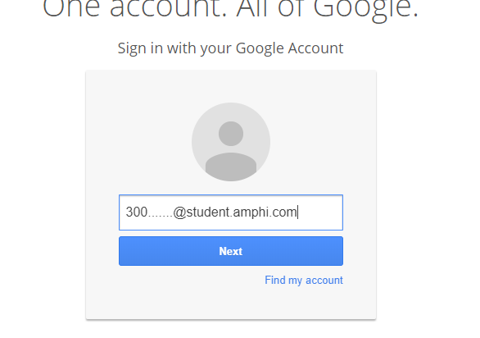
Enter your Amphi Email address and click Next:
300……..@student.amphi.com

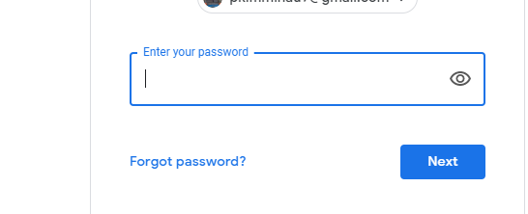
Put in your password: Student’s first name with first letter capitalized and click next.
Note: If you changed your password last year, use that password.

If you have forgotten your password, follow the instructions here.

At this point, you should see a “Link Data” screen. Clicking on this will connect you to your school’s bookmarks.
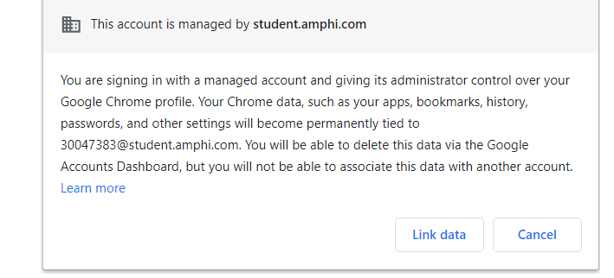
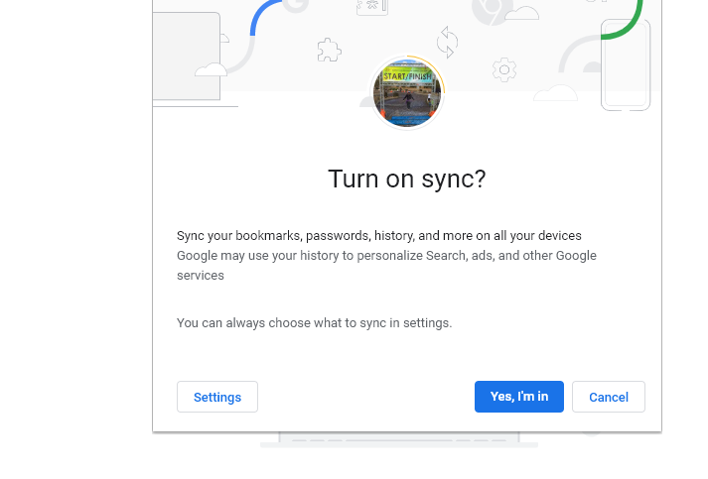
Then click on “Yes,
I’m in”

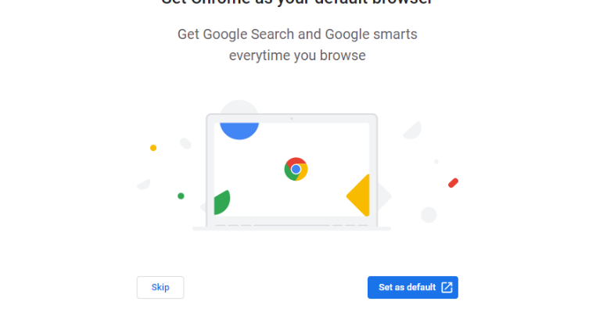
Select Skip

Your school’s bookmarks should be in the upper left on the bookmarks bar.
Kangaroo High School

To get to ALEKS:
- Open school’s bookmarks
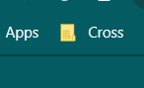

- Select Google Apps

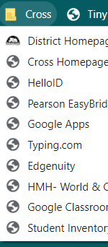

Scroll down to McGraw-Hill and select
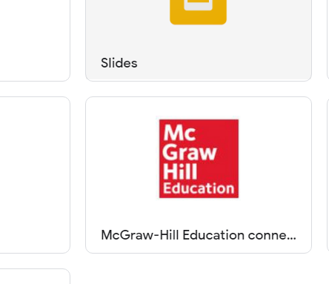

Click on ALEKS “Launch”
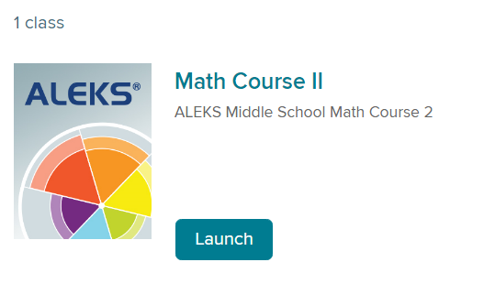

- Have fun with ALEKS!

